Dear Traveller,

It’s not long until we will see you in South America with some of you joining us in time for Rio Carnival, and others just at the start of the trip, and then some in Buenos Aires. We hope you are excited to be starting your South America adventure! Here we have a few more updates for you.

- Traveller information and passport copy
- Sambadrome tickets – last few available & how to download your tickets
- Brazil e-visa reminder
- Camping, accommodation and upgrades
- Trip finish point & date

Note: This update is being sent to everyone booked on various legs of the trip starting in Rio and Buenos Aires so not all the information may apply to everyone.

We will be sending a final update in a couple of weeks’ time with details of your crew, joining instructions, arrangements for your local payment, pre-departure meeting information and contact numbers etc. That will also include instructions about your Sambadrome ticket, if you have booked one.

Traveller information and passport copy
If you have not already completed and returned your Travellers Information Sheet and Passport Copy to us, please do this now as we need the information to book various parts of your trip. You can download the form on our Trip Downloads page, where you’ll find it at the top of the documents list.

We are still missing some people’s travel insurance details, emergency contact details and other information and we need all this before the trip starts.

Rio Carnival - Sambadrome tickets
We have a handful of Sambadrome tickets available so if you don’t have one yet and would like to join our group at this spectacular event, get in touch asap!

As a reminder, we will be heading to the Sambadrome on Monday evening (16th February), which is one of the Special Group parades, featuring 4 of the very best Samba schools in Rio – Mocidade, Beija-Flor, Viradouro and Tijuca. Our tickets are in Sector 10, a grandstand towards the end of the parade which is popular with locals. This means you get to see the whole parade coming towards you and it’s fun to be mixing in a stand with the locals and not just be surrounded by large cruise boat groups or other tourists. It’s an incredible evening's entertainment!

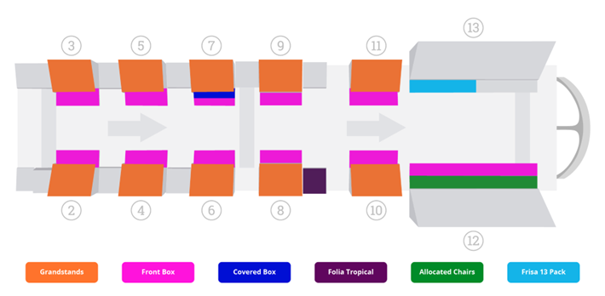

If you have booked Sambadrome tickets with us
Tickets are issued to an online app on your phone. Please download the Quentro app (see below) and register using your email address. Once you have done this, tell us the name and email address you have used so that our local partner Luiz can apply your ticket to your account. Please take care to send us the correct details. If you are travelling with one or more people, then all your tickets can be sent to one registered email address, but be aware that you must enter the Sambadrome together.
Please do this as soon as possible to ensure you receive your tickets in time.

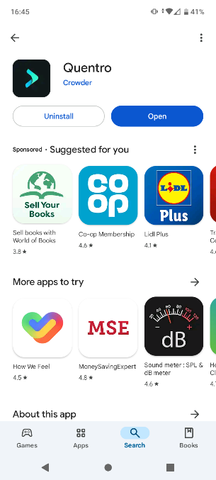

Apple – AppStore - https://apps.apple.com/us/app/quentro/id1446088511
Android – PlayStore - https://play.google.com/store/apps/details?id=com.getcrowder.quentro

There will be around 25 of you going together, with people joining from a few different trips.

We hope you have a wonderful time there and look forward to seeing some pictures of you in your costumes!

Optional Activities in Rio
Our trip that is currently travelling en-route to Rio arrives there in time for Carnival and our local partner Luiz from Be a Local Tours is arranging some activities and excursions for the group. If you will be in Rio and would like to take part in any of the following, please contact Luiz directly. Tell him you are travelling with Oasis Overland and he will do his best to get you on the activity that will be with our group, subject to availability:

Luiz @bealocaltours +5521979731442

Saturday 14th Feb, 9am– Favela Tour
Experience the vibrant culture of Rio’s favelas and learn about the incredible social projects that help their communities. Half day activity in the morning or afternoon.
Cost: 184 Brazilian Reals

Sunday 15th Feb, 8am – Hang Gliding
Amazing adventure tandem flight across Rio, taking off from the mountain in the Tijuca National Park and landing on the beach. Stunning scenery and one of the most popular activities in Rio. Half day activity in the morning.
Cost: 1512 Brazilian Reals

Sunday 15th Feb, 8am – Helicopter Flight
Scenic helicopter flight over Rio’s famous sites including Ipanema and Copacabana beaches, Christ the Redeemer and Sugarloaf Mountain. Approximately 30 minute flight.
Cost will depend how many people are on the flight:
2 people: 1404 Brazilian Reals per person
3-4 people: 1188 Brazilian Reals per person
In addition, you need to pay 324 Brazilian Reals for a car transfer (split between you if more than one in your group – please confirm this with Luiz)

Monday 16th Feb, 8am – City Tour
Explore the city’s most iconic sights, including Christ the Redeemer, Santa Teresa, the Metropolitan Cathedral, the Selarón Steps and Sugarloaf Mountain. Around 5-6 hours – transport is a minibus.
Cost: 486 Brazilian Reals

All activities must be paid for in advance and include an 8% fee for paying by Paypal directly to Be a Local Tours (we will send payment details). No shows are non-refundable. Activities are also available on other dates.
Note – these activities are all operated by Be a Local Tours, not by Oasis Overland. Your communications, payments and arrangements will be managed with them. Whilst we have worked with Luiz for many years, we don’t have previous experience of the helicopter operator (Voos Rio Panorâmico) and so would recommend you check out the safety protocol, insurance info and reviews yourself. It’s a good idea to do this for any adventurous activity. Please also check your own travel insurance to be sure it covers helicopter flights or hang gliding.

Visas
- Brazil visa for Australian, US and Canadian passport holders
Just a reminder that you will need to apply for your Brazil e-visa before arriving in Rio. If you haven’t yet applied, please do so right away - see our previous update for details of how to apply.

Camping, accommodation and upgrades
You will be staying in a mix of accommodation types from campsites, roadside fuel stations and wild camping, to hostels and basic hotels. There is a good amount of camping on this tour, and you should be prepared and ready for that, bringing a sleeping bag and camping mat with you.
When we are not camping, you will sometimes sleep in multi-bed dorms. While we would prefer to book same sex dorms, due to the make-up of the group and available space in hostels, often this isn’t possible and you may sleep in a mixed dorm.
However, if you want to upgrade from shared rooms to a private room (for singles or couples), or to upgrade from camping to a room, you may be able to do that when you arrive at each location, based on availability at the time.
Many of your hostels and camping spots will have been pre-booked and pre-paid well in advance and so, arranging and paying for upgrades is your responsibility, not the tour leaders. Your Tour Leader won't be able to pre-book various different private and upgraded rooms in advance.
If you do upgrade and you are staying in the same place as the rest of the group, then you may be able to use the amount we have paid for your original room, bed or camping spot, towards your upgraded room IF the property allows you to do that. Sometimes they will, but very often they won’t. This is not something we can control, and it is not something the tour leader will have time to haggle about for you. If you stay somewhere else completely, away from the main group, then you will need to cover all your costs for that.
While you are camping, you will be sharing a tent with another traveller in the group (same sex, unless you are a couple already). If you do not want to share, you are welcome to bring your own tent with you, but please let us know if you are doing this.

Trip finishing point
We have had a few people change dates and cancel their trips. And so, at the moment the trip is due to finish in Lima, Peru.
We do have a couple of people booked to continue beyond Lima, as far as Quito, but unfortunately no longer have enough to run that leg of the trip yet.
If you are interested in extending your trip to stay on the truck a little longer, please contact us and we can discuss options for finish dates, locations and prices with you.

