Feb 2026

Dear Traveller,

You will soon be in Rio de Janeiro to start your South America overland adventure! Here is a final update about meeting up with your crew and fellow travellers.

- Sambadrome tickets – reminder to download your tickets
- Joining your Oasis trip in Rio de Janiero - Oasis crew, joining hotel, pre-departure meeting
- Your expedition vehicle – seating & luggage
- Local payment

Rio Carnival - Sambadrome tickets

For those who have booked Sambadrome tickets with us – if you have not already, please download the Quentro app right away and get back to us with the email address and name you used to register:

Tickets are issued to an online app on your phone. Please download the Quentro app (see below) and register using your email address. Once you have done this, tell us the name and email address you have used so that our local partner Luiz can apply your ticket to your account. Please take care to send us the correct details. If you are travelling with one or more people, then all your tickets can be sent to one registered email address, but be aware that you must enter the Sambadrome together.
Please do this as soon as possible to ensure you receive your tickets in time.

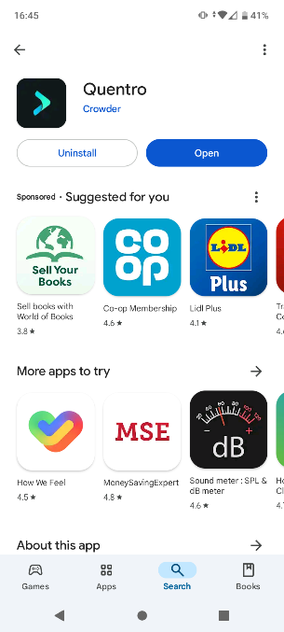

Apple – AppStore - https://apps.apple.com/us/app/quentro/id1446088511
Android – PlayStore - https://play.google.com/store/apps/details?id=com.getcrowder.quentro

Please look out for a notice in reception at the Hotel Riazor about meeting up with our tour leader and group for the Sambadrome night on 16th Feb.

We have a few Sambadrome tickets available so if you don’t have one yet and would like to join our group at this spectacular event, get in touch asap!

Joining your Oasis trip in Rio de Janiero

Oasis Crew
Your crew for this trip are Jordan and Adrian and both have bags of travel experience. Jordan is an experienced tour leader and logistics co-ordinator and led our first northbound Trans Africa from Cape Town to Fes last year. Adrian drove his first overland trip in the 1990s and continued to take expeditions across South America, Africa and Asia over several years. More recently he drove from Istanbul to Beijing and Kathmandu. We are excited to have Jordan and Adrian leading your South America adventure and they are looking forward to meeting you!

Trip Joining Point – Rio
Hotel Riazor
Address: Rua do Catete, 160 - Catete, Rio de Janeiro
Telephone: +55 21 2225-0121
https://www.hotelriazor.com.br/?lg=en
Start Time Day 1: 08:00 (to be reconfirmed at the pre-trip meeting)

If you are starting in Rio and have booked our pre-trip package over Carnival, then you can check into the hotel in the afternoon of the 13th February. Adrian and Jordan will arrive at the Riazor on 17th February.

Pre-departure Meeting
An initial pre-departure meeting will be in the hotel at 7pm the evening before your trip starts, 17th February. Here Jordan will explain how the day to day running of the trip works. He will collect your Local Payment money as well as 2 photocopies of your passport information page. It is important that you attend this meeting so please let us know if you are unable to do so.

If you need to contact Jordan once you are in Brazil if your flights are delayed and you think you won’t be there on time, you can WhatsApp him on +44 7742719008. Please remember to tell him who you are! Please also hold off contacting him until a couple of days before your start date at least, as he will be busy preparing for your trip and not readily available.
Our UK 24 hour emergency number if you can’t reach Jordan is +44 203 633 3041.

Local Payment
Remember to have your local payment ready to pass onto Jordan at the pre-departure meeting. You may find it easiest and cheapest to book this online to pick up at your departure airport. This should give you a good rate and save you carrying a lot of cash for a long time before the trip starts. Please bring larger $50/$100 notes for your LP.

If anyone has concerns about obtaining or taking large amounts of cash in to Rio for their local payment, we are willing to make arrangements for this to be paid to us here in the UK instead. We will need to cover our bank conversion rates and card fees, but if you want to do it, please let us know.
Rio to Santiago - $2100 – GBP 1615
Rio to Lima - $3000– GBP 2310
Rio to Quito - $3700 – GBP 2846
Please remember that if you leave the trip by choice for any period of time or cut your trip short and finish early, then the normal rules apply and there will be no refunds of local payment.

Expedition Vehicle
The vehicle that we will be using for this trip has one that we have sourced for our trips since the Covid pandemic, when we lost the use of some of our trucks in South America for varying reasons. The layout is a bit different, with the majority of seats all facing forwards, and just a couple of tables with some seats facing the other way. The main luggage storage is accessible from outside the truck, not from under your seat cushion. It also has a fridge :)

We hope you have an incredible time in South America! Please do share your photos on Facebook and Instagram, we love to see them!

