To: HM Passport Office

ENTER DATE

Re: Additional or Frequent Traveller Passport application

Dear Sir / Madam,

This letter is written to provide context and further information with regard to the traveller named below and their application for an additional or frequent traveller passport.

Name: ENTER YOUR NAME
Trip booked: ENTER TRIP NAME
Trip URL: ENTER WEBSITE LINK TO TRIP PAGE
Booking ID: ENTER BOOKING ID
Start date & location: ENTER START DATE2
Finish date & location: ENTER END DATE
Duration: ENTER DURATION IN WEEKS
Number of countries visited: ENTER NUMBER OF COUNTRIES

The person named above is a confirmed traveller on our trip named above. This is a long, overland expedition, which takes in multiple countries and will require many clear passport pages for the required visas and passport stamps at each border crossing.
There will be no opportunity to renew an existing passport during the trip.
The traveller will therefore need an additional, concurrent second passport or a 50-page frequent traveller passport in order to complete the trip.

We would appreciate your assistance with providing them with a new passport to enable them to complete their booked travel with us.

If you need any more information from us about their trip, please do not hesitate to contact me at the details above.

Yours faithfully,

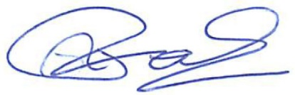

Ralph Foulds
Managing Director, Oasis Overland

