Hi everyone,

Just a few weeks to go until you set off on your expedition! This is our update about meeting us in Gibraltar or Fez, instructions for paying for your Cote d’Ivoire (Ivory Coast) visa, a one way flight letter and a few reminders.

If you haven’t already, please email us your flight arrival details so we know who is arriving when and where.
It’s very important that we know whether you are joining in Gibraltar or Fez so please let us know this along with your flight details by 25th October. We need to buy Spain-Morocco ferry tickets and Tangier-Fez train tickets for everyone who needs them.
Your Tour Leader, Chris Blake and Driver, Mark Dawson will be in Fez with our expedition truck to meet those of you arriving into Morocco. Unfortunately Al, who you may have heard on our Zoom call cannot travel for medical reasons. Dawso has bags of experience however, having led our 2022 departure.
Ant from our UK office will meet those of you arriving into Gibraltar and will accompany you by local transport to Fez where everyone will meet on 12th November. Later in the day there will be a pre-departure meeting with Chris and Mark to prepare you for the journey ahead!

Meeting Mark and Chris, in Fez on day one
Make your way to Diamant Vert Bungalows in Fez where Chris and Mark will meet you on 12th November:
Address: Rte Ain Chqef, Fez 30000, Morocco
https://www.booking.com/hotel/ma/diamant-vert.en-gb.html
Phone: +212 5356-08369
Please arrive as soon as you are able so Chris can make a start on paperwork and collecting your Local Payment ahead of the pre-departure meeting. The camp is not really ideal if you want to book pre-tour nights. The location is a bit outside of town, and while it has some bungalows, they aren’t that great really. We use it because it has space for the truck and camping, which places in town just don't. If you arrive a day or more early, you will probably be better off booking somewhere in the heart of Fez. You'll have much better access to look around the city, and could just get a taxi out to join the trip on the 12th.
If you need to contact Chris once you are in Morocco, you can Whatsapp him on +44 798 390 2315. Please remember to tell him who you are!
Our UK 24 hour emergency number if you can’t reach him is +44 203 633 3041.

Meeting Ant in Gibraltar on day one
Ant will meet you early morning on 12th November on the Spanish side of the Gibraltar border by the airport. Please be there at 08.00am. If everyone arrives on time we should have plenty of time and not be rushed getting to the ferry.

Ant will be waiting on the Spanish side of the border line shown (i.e. above the line) immediately after you cross over. See on the map below. He will be holding an Oasis sign so you can easily spot him! It is a short walk from the airport arrivals area to the border and is well signposted.

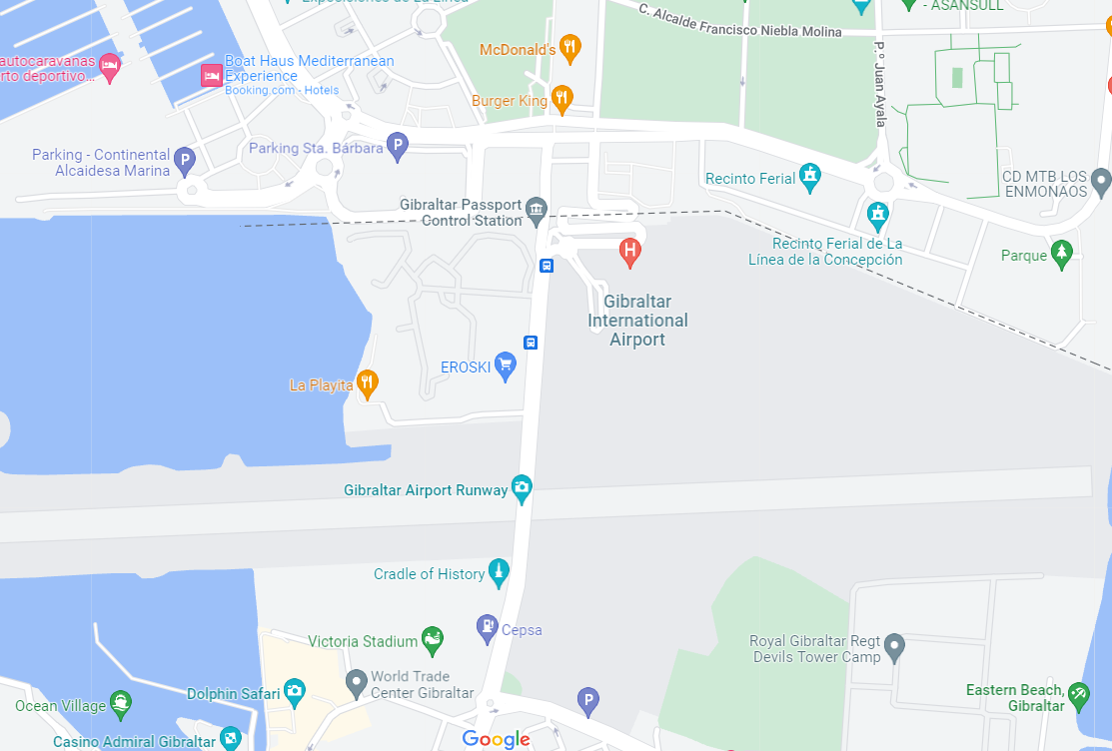

IMPORTANT - If you are a non-EU citizen (including British citizens) you must get your passport stamped at the border to show you are exiting the UK and entering the EU. The officers sometimes just wave people through, but you do need this stamp to enter Morocco later.
From here Ant will arrange transport and escort you to the port for your ferry from Tarifa to Tangier Ville, and onward journey by train to Fez.
If you need to contact Ant once you are in Gibraltar, you can Whatsapp him on +44 7467 476552. Remember to tell him who you are and please do only use this number for the purposes of meeting on day 1 only.
Our UK 24 hour emergency number if you can’t reach him is +44 203 633 3041.

Cote d’Ivoire visa
You will need to start your Cote d’Ivoire visa application online before the start of your trip. You do not need to complete your application, but you do need to pay for your visa and make an appointment for the visa application at an Embassy. The process only takes a few minutes to complete. Please see the ‘pre-trip-ta-nov23 4.2 - Cote d’Ivoire visa payment and appointment’ document for instructions on how to do this.
On the note of visas – please be aware that you will need to bring a set of ‘embassy clothes’ with you, so that you can wear these to the embassies when you are applying for visas. These need to be smart, so a pair of closed shoes (no flip flops!), long length trousers or skirts (jeans are not acceptable in some embassies) and a collared or smart top, covering your shoulders.

Local Payment
Please remember to bring your Local Payment in US Dollars and Euros cash as per the breakdown in our previous update (See pre-trip-ta-nov23 3.1 local payment on the Trip Downloads page). Chris will collect this from you at the start of the trip.

Document copies
Please don’t forget to bring with you on the expedition, the document copies listed in our previous update (pre-trip-ta-nov23 3 document-copies-lp-liability-insurance-travel-advice-travel-insurance). This will save you a lot of hassle finding printing and copying facilities en route! In addition to the documents listed, please also ensure you have several copies of your Covid vaccination record.
We are also still missing electronic copies of passports, yellow fever certificates etc. from various people. Please could you send these in asap. as it is important for the crew to have access to these and it is much easier to do it now than while already en-route.

Tents
If you are planning to bring your own tent, please let us know right away so we can manage the number of our own tents that we bring. If you are unsure whether you have told us or not, please tell us again. If you do not bring your own tent, you should expect to share a tent with another member of the group. On this trip we will be using 2-person A-Frame tents rather than dome tents.

Luggage
Please remember that although the truck is roomy with lots of storage areas, there is a limit to space for your personal luggage and we will be full with stocks to take us through West Africa as well as all the kitchen equipment, spare parts & tools etc. So, 80 litre (100ltr max) backpacks and holdalls are the best form of carrying your luggage which will be stored in lockers on the outside of the truck, along with a small day pack (40ltr max) that you can store on the overhead rack inside the truck. Backpacks and holdalls that have a rigid frame as well as suitcases are impractical on the truck and should not be brought. If you bring excess luggage above the recommended amount then you will need to post it home from Morocco.

Personal spending money
As a UK company, much of our spending money suggestions are quoted in Pounds sterling however, we do suggest that you bring mainly US Dollars and Euros as outside The Gambia and Southern to Eastern Africa, the Pound generally attracts a less than favourable rate or is not possible to exchange at all.
It is advisable to anticipate needing more spending money and we always advise to have a contingency fund. Also, remember that our personal spending money suggestions do not include paying for Optional Excursions or visas, therefore these should be accounted for separately.

One-way flight letter
Sometimes immigration officers or airline check in staff may question why you only have a one-way ticket. We have therefore prepared a template letter which you can amend and print out to explain your onward travels with us.

This should be the final update from us, so the last thing to say is have an incredible trip across Africa!
We look forward to seeing your photos and hearing stories from the trip.

