Cote d’Ivoire (Ivory Coast) visa payment and appointment

You will need to start your application for your visa for Cote d’Ivoire online before the start of your trip. This is to pay for your visa and make an appointment for the visa application at the Embassy.

Part one of the visa process is simply paying for your visa online:

- Go to https://snedai.com and click on ‘Obtenir un visa dans les ambassades’
- You can change this page to English by clicking on the British flag at the top of the page
- Scroll down the page to ‘2 – Payment’. Click on the link at the bottom of the paragraph: https://snedai.com/paiementFastraceFR
- This is the payment page for the visa. You can change the language to English again at the top. Make sure the product is Visa for Ivory Coast valid for 3 months, the total cost will be €58 including taxes. If there are two of you, make sure you pay for each person’s visa individually, as the system does not recognise payment for more than one person. Click ‘Next’
- Fill in your personal details as required. Click ‘Next’
- Fill in payment details (note include the spaces in your card number) and click ‘Yes, I confirm my payment’.
- The following screen will appear. You will also receive this in an email.

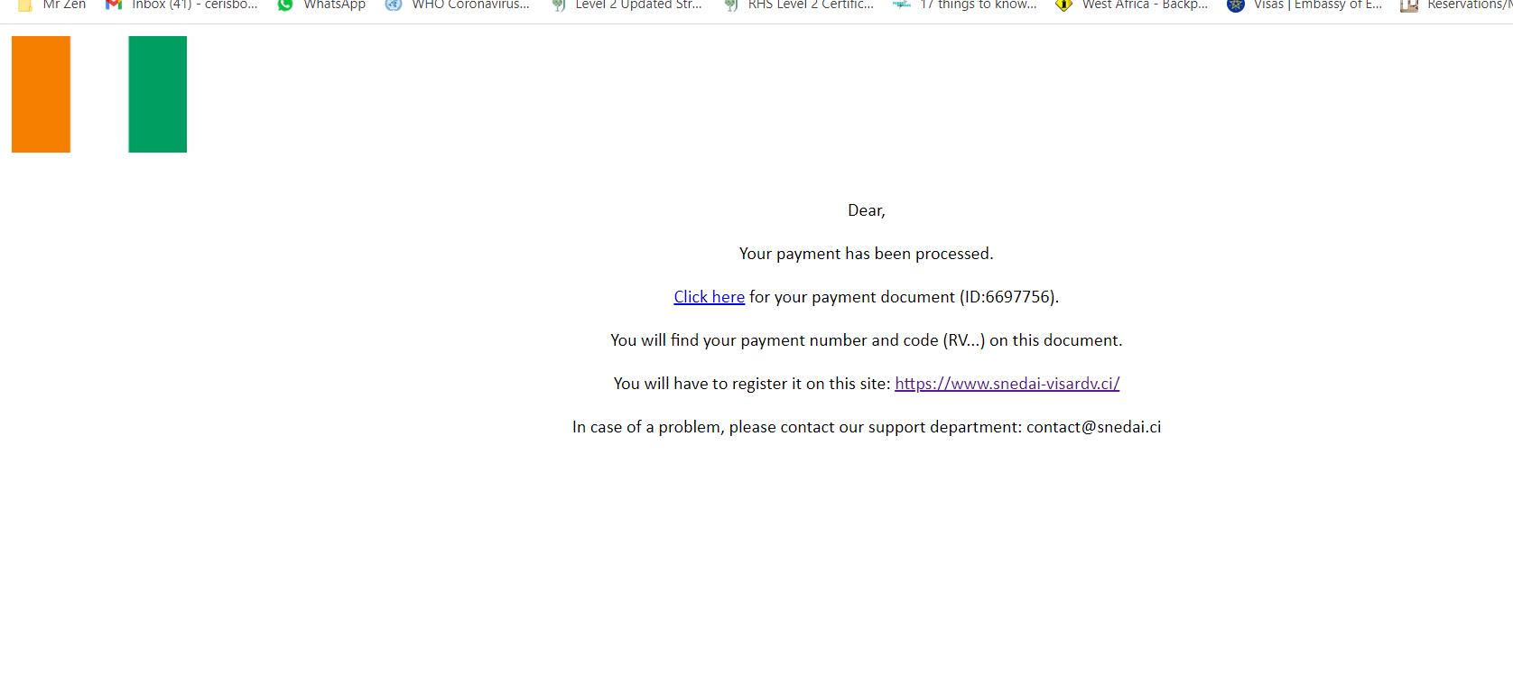

- Hit ‘Click here’ to print your receipt. Black and white copies are acceptable.

Next you need to make an appointment:

- Follow the link on the webpage or email you received stating “you will have to register this on” https://www.snedai-visardv.ci/
- Change language to English – top right hand side of page.
- Click on the tab ‘Making Appointments’ – left hand menu
- Read and Approve – Click ‘Next’
- Enter your Code Voucher starting with RV ..... and fill in the details.
- Confirm your email address.
- Enter Last name
- Enter First name
- Enter phone number
- Click ‘Next’
- Confirm email
- Choose Country from drop down box - ‘Senegal’
- Choose Date and Time – 12th December 2023, 9H30 – 12H00
If this date is not available, choose the soonest date and time after it, e.g. 13th, 14th, 15th, 16th, 17th December.
- Click ‘Validate’
- You should receive an email confirming your appointment time however, from our recent experience this has not always worked correctly. If it does work, please print the email (black and white copies are acceptable).

If it doesn’t and you just see a page stating ‘Loading’, please follow these steps:

- Go to https://www.snedai-visardv.ci/visa/
- Click ‘View/Modify appointment’ – left hand menu
- Enter Enter your Code Voucher starting with RV .....
- A page with your confirmed appointment will appear. Please print this off (black and white copies are acceptable).

Then you are all done!

Please remember to bring the 2 printed documents with you on the trip, as you will need to show this to the consul when we apply for the visa.

Once you are with your crew and group, you will fill in the necessary visa forms and then when you are at the embassy you will be required to scan your fingerprints.

Could everyone please confirm receipt of this update.

If you have any questions, please let us know.

