3 Feb 2026

Dear Oasis Traveller,

It’s not long until we will see you in South America with some of you joining us in time for Rio Carnival, and others just at the start of the trip. Some of your fellow travellers are already on the road having started their journey with us in Cartagena or Buenos Aires. We hope you are excited to be starting your South America adventure! Here we have a few more updates for you.

- Traveller information and passport copy
- Sambadrome tickets – last few available & how to download your tickets
- Optional Activities in Rio
- Visas – Brazil reminder and Suriname Entry Fee
- Joining your Oasis trip in Rio de Janiero - Oasis crew, joining hotel, pre-departure meeting
- Local payment
- Camping, accommodation and upgrades
- Itinerary update

Traveller information and passport copy
If you have not already completed and returned your Travellers Information Sheet and Passport Copy to us, please do this now as we need the information to book various parts of your trip. You can download the form on our Trip Downloads page, where you’ll find it at the top of the documents list.
We are still missing some people’s travel insurance details, emergency contact details and other information and we need all this before the trip starts.

Rio Carnival - Sambadrome tickets
We have a handful of Sambadrome tickets available so if you don’t have one yet and would like to join our group at this spectacular event, get in touch asap!

As a reminder, we will be heading to the Sambadrome on Monday evening (16th February), which is one of the Special Group parades, featuring 4 of the very best Samba schools in Rio – Mocidade, Beija-Flor, Viradouro and Tijuca. Our tickets are in Sector 10, a grandstand towards the end of the parade which is popular with locals. This means you get to see the whole parade coming towards you and it’s fun to be mixing in a stand with the locals and not just be surrounded by large cruise boat groups or other tourists. It’s an incredible evening's entertainment!

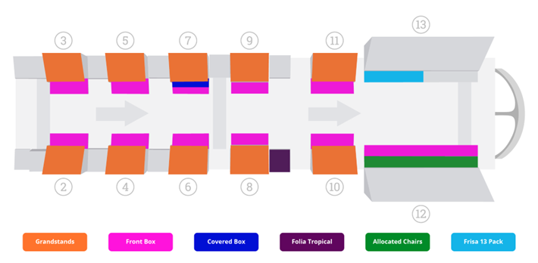

If you have booked Sambadrome tickets with us
Tickets are issued to an online app on your phone. Please download the Quentro app (see below) and register using your email address. Once you have done this, tell us the name and email address you have used so that our local partner Luiz can apply your ticket to your account. Please take care to send us the correct details. If you are travelling with one or more people, then all your tickets can be sent to one registered email address, but be aware that you must enter the Sambadrome together.
Please do this as soon as possible to ensure you receive your tickets in time.

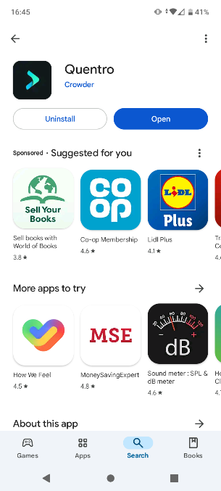

Apple – AppStore - https://apps.apple.com/us/app/quentro/id1446088511
Android – PlayStore - https://play.google.com/store/apps/details?id=com.getcrowder.quentro

There will be around 25 of you going together, with people joining from a few different trips.

We hope you have a wonderful time there and look forward to seeing some pictures of you in your costumes!

Optional Activities in Rio
Our trip that is currently travelling en-route to Rio arrives there in time for Carnival and our local partner Luiz from Be a Local Tours is arranging some activities and excursions for the group. If you will be in Rio and would like to take part in any of the following, please contact Luiz directly. Tell him you are travelling with Oasis Overland and he will do his best to get you on the activity that will be with our group, subject to availability:

Luiz @bealocaltours +5521979731442

Saturday 14th Feb, 9am– Favela Tour
Experience the vibrant culture of Rio’s favelas and learn about the incredible social projects that help their communities. Half day activity in the morning or afternoon.
Cost: 184 Brazilian Reals

Sunday 15th Feb, 8am – Hang Gliding
Amazing adventure tandem flight across Rio, taking off from the mountain in the Tijuca National Park and landing on the beach. Stunning scenery and one of the most popular activities in Rio. Half day activity in the morning.
Cost: 1512 Brazilian Reals

Sunday 15th Feb, 8am – Helicopter Flight
Scenic helicopter flight over Rio’s famous sites including Ipanema and Copacabana beaches, Christ the Redeemer and Sugarloaf Mountain. Approximately 30 minute flight.
Cost will depend how many people are on the flight:
2 people: 1404 Brazilian Reals per person
3-4 people: 1188 Brazilian Reals per person
In addition, you need to pay 324 Brazilian Reals for a car transfer (split between you if more than one in your group – please confirm this with Luiz)

Monday 16th Feb, 8am – City Tour
Explore the city’s most iconic sights, including Christ the Redeemer, Santa Teresa, the Metropolitan Cathedral, the Selarón Steps and Sugarloaf Mountain. Around 5-6 hours – transport is a minibus.
Cost: 486 Brazilian Reals

All activities must be paid for in advance and include an 8% fee for paying by Paypal directly to Be a Local Tours (we will send payment details). No shows are non-refundable. Activities are also available on other dates.
Note – these activities are all operated by Be a Local Tours, not by Oasis Overland. Your communications, payments and arrangements will be managed with them. Whilst we have worked with Luiz for many years, we don’t have previous experience of the helicopter operator (Voos Rio Panorâmico) and so would recommend you check out the safety protocol, insurance info and reviews yourself. It’s a good idea to do this for any adventurous activity. Please also check your own travel insurance to be sure it covers helicopter flights or hang gliding.

Visas
- Brazil visa for Australian, US and Canadian passport holders
Just a reminder that you will need to apply for your Brazil e-visa before arriving in Rio. If you haven’t yet applied, please do so right away - see our previous update for details of how to apply.

- Suriname
Most nationalities are visa free and only need to register and pay an Entry Fee online. Please see the accompanying instructions for how to apply for the Entry Fee.

- French Guiana & Guyana
These are currently visa free for most nationalities.

Joining your Oasis trip in Rio de Janiero

Oasis Crew
Your crew for this trip are Emily and Ritchie and both have bags of travel experience. Ritchie is an experienced overland driver having taken trips throughout South America for 8 years prior to 2020. After a well earned break, he returned to South America and to overlanding across this incredible continent. Emily has been leading our Cartagena to Rio trip which started in October last year and previous to that spent almost a year travelling South America. With a Colombian mom and proficient Spanish, she feels a special connection to this continent. We are excited to have Emily and Ritchie leading your South America adventure and they are looking forward to meeting you!

Trip Joining Point – Rio
Hotel Riazor
Address: Rua do Catete, 160 - Catete, Rio de Janeiro
Telephone: +55 21 2225-0121
https://www.hotelriazor.com.br/?lg=en
Start Time Day 1: 08:00 (to be reconfirmed at the pre-trip meeting)

If you are starting in Rio and have booked our pre-trip package over Carnival, then you can check into the hotel in the afternoon of the 13th February. The current group you will be joining are arriving that afternoon/evening too. Ritchie and Emily will be staying in the same hotel but they will be taking a well earned break over Carnival so while they will introduce you to the rest of the group and will be accompanying the group to the Sambadrome, they will not be on hand as they normally would be during these days.

Pre-departure Meeting
An initial pre-departure meeting will be in the hostel the evening before your trip starts, 17th February. Please check for a notice in Reception advising you of the exact time (normally 6pm) or of any necessary changes. Here Emily will explain how the day to day running of the trip works. She will collect your Local Payment money as well as 2 photocopies of your passport information page. It is important that you attend this meeting so please let us know if you are unable to do so.
We will then leave Rio at 8am on the morning of 18th Feb.

If you need to contact Emily once you are in Brazil or if your flights are delayed and you think you won’t be there on time, you can WhatsApp her on +1 (928) 420-9428. Please remember to tell her who you are! Please also hold off contacting her until a couple of days before your start date at least, as she will be busy with the group and preparing for your trip and not readily available.
Our UK 24 hour emergency number if you can’t reach Emily is +44 203 633 3041.

Local Payment
Remember to have your local payment ready to pass onto Emily at the pre-departure meeting. You may find it easiest and cheapest to book this online to pick up at your departure airport. This should give you a good rate and save you carrying a lot of cash for a long time before the trip starts. Please bring larger $50/$100 notes for your LP.

If anyone has concerns about obtaining or taking large amounts of cash in to Rio for their local payment, we are willing to make arrangements for this to be paid to us here in the UK instead. We will need to cover our bank conversion rates and card fees, but if you want to do it, please let us know.
Rio to Manaus - $2300– GBP 1780
Rio to Belem - $1500– GBP 1160
Please remember that if you leave the trip by choice for any period of time or cut your trip short and finish early, then the normal rules apply and there will be no refunds of local payment.

Camping, accommodation and upgrades
You will be staying in a mix of accommodation types from campsites, roadside fuel stations and wild camping, to hostels and basic hotels. There is a good amount of camping on this trip, and you should be prepared for that, bringing a sleeping bag and camping mat with you.
When we are not camping, you will sometimes sleep in multi-bed dorms. While we would prefer to book same sex dorms, due to the make-up of the group and available space in hostels, often this isn’t possible and you may sleep in a mixed dorm.
However, if you want to upgrade from shared rooms to a private room (for singles or couples), or to upgrade from camping to a room, you may be able to do that when you arrive at each location, based on availability at the time.

Many of your hostels and camping spots will have been pre-booked and pre-paid well in advance and so, arranging and paying for upgrades is your responsibility, not the tour leader’s. Your Tour Leader won't be able to pre-book various different private and upgraded rooms in advance.
If you do upgrade and you are staying in the same place as the rest of the group, then you may be able to use the amount we have paid for your original room, bed or camping spot, towards your upgraded room IF the property allows you to do that. Sometimes they will, but very often they won’t. This is not something we can control, and it is not something the tour leader will have time to haggle about for you. If you stay somewhere else completely, away from the main group, then you will need to cover all your costs for that.

While you are camping, you will be sharing a tent with another traveller in the group (same sex, unless you are a couple already). If you do not want to share, you are welcome to bring your own tent with you, but please let us know if you are doing this.

Rio to Manaus itinerary update
On a final note, we have been working on our Rio to Manaus itinerary, looking at feedback from our previous travellers and crew and researching where we can make improvements. Following is a summary of the amendments we’ve made which include some great additions.

Brazil
We have replaced a stop in Porto Seguro with two nights in Trancosco. The coast here is declared by many from celebrities to backpackers to be one of Brazil’s best beaches. Since its origins as a small fishing village, Trancosco evolved to become a hippie hangout and more recently gained a reputation as a bohemian beach town. It retains its laid back village feel with local cafes to watch the world go by from and the long sandy beach backed by palm trees is the perfect place to relax and swim.

French Guiana
Suitable accommodation options in Cayenne itself are very limited for our group size and truck and so we will base ourselves 30km outside the city in Roura. We will drive the truck into the city to provide transport in and out so you can spend the day there. We plan to have an additional day in Roura for anyone that wants to have more time in Cayenne.

Suriname
We will no longer stop en route to St Laurent du Maroni to visit the Giant Leatherback Turtle nesting site. Instead it’s possible to book an excursion to a site near Paramaribo in Suriname which our previous travellers found to be a much more informative and overall better experience.

Jungle trips
The following trips are included in the cost of your trip:
Suriname – 2 nights in a jungle lodge near the foot of Felullasifalls on the Suriname River. Time to explore the surrounding Amazon rainforest and several Maroon villages. Here we will learn about the Saramaccan culture and visit local villages. You could also go looking for caimans on a nocturnal cruise, and swim from a sandy beach or enjoy a natural jacuzzi in the rapids. You need to pay for drinks and any craft items but activities and meals are included.
Guyana – 2 nights in a forest reserve. We will bring the truck here and camp for a couple of nights on the Essequibo River on the edge of the Iwokrama Forest. No included activities.
Brazil – overnight at a jungle lodge in the Amazon rainforest. This excursion takes you around 200kms from Manaus into the Amazon where you can search for wildlife and discover more of the different indigenous people who live in the area. There are chances to learn about different plant species that are used for medications, fish for piranhas, and take guided walks in the forest. You need to pay for drinks and any craft items but activities and meals are included.

Flights to the Kaieteur falls – In Georgetown, Guyana, 7 & 8 April
Your tour leader, Emily, will update you about these. But it is worth mentioning now too. These flights can sell out well in advance, and don’t operate every day, so we need to manage expectations about them. Sometimes flights only operate at weekends, and all flights can get booked up quickly. Even if you have a booking they are weather dependent on the day and can be cancelled last minute. You may need to pay by bank transfer to confirm the booking. Prices can be from US$300-$350. Options for booking these flights include:
Wilderness Explorers +592 625 4672
592 Tours +592 662 7580
Dagron Tours +592 650 4758
Evergreen Tour +592 691 0431
Old Fort Tours +592 662 5502

Trip end date
With any of our longer overland trips like this, we recommend that you do not plan to fly out until at least a day after the trip finishes. That would be 21st April.
If you have flights out of Manaus on 20th April, please let us know as soon as possible as this may impact the jungle trip we can arrange (we may not arrive back into Manaus from this trip on our final day until the afternoon of 20th April).

We hope you have an incredible time in South America! Please do share your photos on Facebook and Instagram, we love to see them!

