03 Sep 2025
Dear Traveller,

It’s just a few weeks until some of you join us and your fellow travellers in Cartagena. Currently there are 18 of you starting in Colombia with a few more joining in Santiago and Buenos Aires. We hope you are excited to be starting your South America adventure! Here we have a few more updates for you.

Your crew for this trip are Emily and Martin and both have bags of travel experience. Martin is an experienced overland driver with his journeys including from Istanbul to Beijing and back as well as driving tours through both Afghanistan and Iraq. He is also a skilled mechanic, having built his own overland vehicle, not to mention completely rebuilding an engine in Tajikistan! Emily spent the last two years travelling, volunteering, and working abroad, including nearly a year in South America, where she visited every country on our route. With a Colombian mom and proficient Spanish, she feels a special connection to South America and loves sharing it with others. We are excited to have Emily and Martin leading your South America adventure and they are looking forward to meeting you!

Note: Your overland truck for this trip will be larger and have forward facing seats, a different layout to our normal South America vehicles. And a fridge :)

Trip Joining Point - Cartagena
Hostal Casa Torres
Address: Cl de la moneda 7 - 110 Historic Center, Cartagena
Telephone: +57 313 872 7468
Website: www.hostalcasatorres.com
Email: recepcioncasatorres@gmail.com
Start Time Day 1: 08:00 (to be reconfirmed at the pre-trip meeting)

The entrance to this hostel is pretty unassuming – these may help...
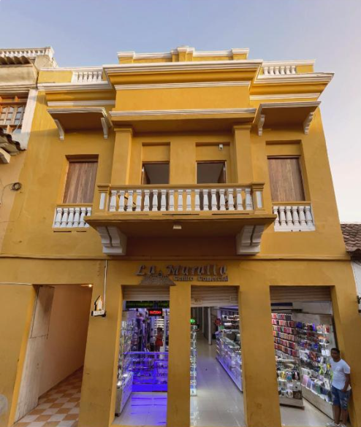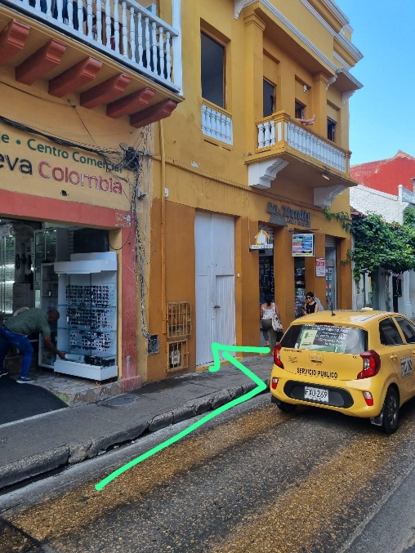

Local Payment
Remember to have your local payment ready to pass onto Emily at the start of the trip. You may find it easiest and cheapest to book this online to pick up at your departure airport. This should give you a good rate and save you carrying a lot of cash for a long time before the trip starts. Please bring larger $50/$100 notes for your LP.
If anyone has concerns about obtaining or taking large amounts of cash in to Cartagena for their local payment, we are willing to make arrangements for this to be paid to us here in the UK instead. We will need to cover our bank conversion rates and card fees, but if you want to do it, please let us know.
Cartagena to Manaus - $5000 – GBP 3890
Cartagena to Rio - $4400 – GBP 3423
Cartagena to Ushuaia - $3500 – GBP 2723
Cartagena to Quito - $900 – GBP 700
Please remember that if you leave the trip by choice for any period of time or cut your trip short and finish early, then the normal rules apply and there will be no refunds of local payment.

Pre-departure Meeting
There will be a pre-departure meeting in the starting hotel the night before the start of the trip. This will be in the breakfast room of the hostel around 8.00pm on 1st October - there will be a notice in reception confirming this and advising the exact time. Here Emily will explain how the day to day running of the trip works. She will collect your Local Payment money as well as 2 photocopies of your passport information page. It is important that you attend this meeting so please let us know if you are unable to do so.
If you need to contact Emily once you are in Colombia/Ecuador or if your flights are delayed and you think you won’t be there on time, you can WhatsApp her on +1 (928) 420-9428. Please remember to tell her who you are! Please also hold off contacting her until a couple of days before your start date at least, as she will be preparing for your trip and not readily available.
Our UK 24 hour emergency number if you can’t reach Emily is +44 203 633 3041.

Colombia Immigration Form - Cartagena joiners:
To speed up your entry on arrival in Colombia, you can fill out the ‘Check-Mig’ form available on the Migración Colombia website, between 72 hours and 1 hour before your flight to Colombia departs. You can enter the name and address of our joining hotel as the place where you are staying in Colombia.
The form is no longer mandatory but airlines may still require it. There is no fee payable when completing the form on the official site above but visa agencies or 3rd party websites may offer a chargeable service to submit the form for you.
You will receive a confirmation email that you can present before boarding your flight and, if asked for it, upon arrival in Colombia. You are also required to show an onward ticket so please have your flight ticket home and your Oasis confirmation email and itinerary ready in case you are asked to show those. If you don’t have a flight ticket home yet, you can use the ‘letter for one way flight’ template accompanying this update to prove your overland departure from Colombia.

Updated Bolivia visa info for US passport holders - only applies to those travelling through Bolivia
As advised previously, US citizens can apply for this at the Bolivian border but also at an embassy during the trip, time allowing, e.g. Cusco. Getting it at the border can take a long time. The visa costs approximately US$160. You will need to fill out an online application form and upload the following documents:
- Passport scan
- Yellow fever scan
- Passport photo
- Your most recent bank statements from the past 3 months.

You will then need to print out your application and take this along to the embassy or immigration at the border, along with:
- 2 passport-sized photographs (3cm x 4cm)
- Letter from Oasis confirming your itinerary
- Hotel bookings – your Tour Leader will advise whether our Bolivia accommodation have provided these or if you need to make bookings on a hotel booking platform that you can cancel at a later date.

You can apply for your visa in advance if you wish but please check how long it is valid for you to enter Bolivia. Valid for entry is different from the length of stay allowed. For example, if your visa is valid for entry for 30 days from the date of issue and you’re starting your trip in Cartagena, your visa will expire before reaching Bolivia.

Most other nationalities do not require a visa but you can check here: https://bolivianembassy.co.uk/visas-de-turismo/

Chile visa for Australian passport holders - only applies to those travelling through Chile

A template letter from Oasis to support your Chile visa application accompanies this update.

Remember that you must not apply too early as the visa is valid for entry for 60 days from the date of issue. We are due to enter Chile in mid-December so you should not apply before the end of October. If joining the trip before then, you should apply during the trip in Lima. If joining us after that and you are confident you have time to process the visa without it being issued too early, you can apply in Australia.

Please see our previous update for instructions on how to make your application.

Brazil visa for Australian, US and Canadian passport holders - only applies to those travelling through Brazil

Please see the accompanying instructions for how to apply for your e-visa, along with a template letter from Oasis to support your application.

Remember that visas are usually valid for entry for 3 months from date of issue, so you should not apply before the end of October.

Camping, accommodation and upgrades
As you will have seen on our website, you will be staying in a mix of accommodation types from campsites, roadside fuel stations and wild camping, to hostels and basic hotels. In some of these you will sleep in dorms. We always aim for same sex dorms but sometimes this is not possible and you will be sleeping in a mixed dorm.
If you want to upgrade from shared rooms to a private room (for singles or couples), or to upgrade from camping to a room, you can do that when you arrive at each location, based on availability at the time. Many of your hostels and camping spots will have been pre-booked and pre-paid well in advance and so, arranging and paying for upgrades is your responsibility, not the tour leaders. Your Tour Leader is not going to be able to pre-book various different private and upgraded rooms in advance.
If you do upgrade and you are staying in the same place as the rest of the group, then you may be able to use the amount we have paid for your original room, bed or camping spot, towards your upgraded room IF the property allows you to do that. Sometimes they will, but very often they won’t. This is not something we can control, and it is not something the tour leader will have time to haggle about for you. If you stay somewhere else completely, away from the main group, then you will need to cover all your costs for that.
While you are camping, you will be sharing a tent with another traveller in the group (same sex, unless you are a couple already). If you do not want to share, you are welcome to bring your own tent with you, but please let us know if you are doing this.

ADD ONS
Lastly, here is a reminder about the W-trek in Chile and Rio Carnival accommodation and Sambadrome tickets. We do have limited numbers of places left for all of these. But we will need to release the space we are holding several months before you get there. So, please let us know as soon as possible if you are interested in booking any of these.
- CHILE – W Trek
For those travelling beyond Santiago, we have places available on the W Trek.
While we are in Argentina, we spend several days in Puerto Natales, right next to Torres del Paine National Park. While you are there, there is an option available to do the W Trek priced at £1060 per person. This covers a 4 day/3 night W Trek arranged by our local partners there, as well as a night at their accommodation in Puerto Natales before and after the trek.
Places are on a first come first served basis. The W Trek is one of the world’s most famous treks, and is a challenging walk with some tricky terrain and steep ascents and descents. You do not need to be a specialist or experienced hiker to complete the trek, but you do need to be in moderate to good health with a decent level of fitness. You will be carrying your own backpack with sleeping bag and mat (both sleeping bag and mat provided, though you will have your own for the trip anyway) and clothes for the trek. The four hiking days are approx. 18km (7-8hrs), 14.5km (6.5hrs), 20.3km (9hrs) and 11km (3.5hrs).
For more detailed information about the W Trek arrangements, inclusions/exclusions etc., go to the trip page on our website, click on the ‘Essential Information’ tab, and then the ‘Additional Information’ section.
If you do not want to do the trek, then you can remain in Puerto Natales and take day trips into Torres del Paine National Park from there. We include an entry ticket for you in our trip price. This would include being able to do the famous Base of the Towers trek together with the W Trek group on their first day (but returning back to Puerto Natales afterwards). All these day trips can be arranged while you are in Puerto Natales – there is nothing you need to do now.

What to do now…
- Tell us as soon as possible if you want to do the W Trek (if you haven’t already).
- So that we can confirm camping spots, permits and accommodation for you, full payment is due at the time of booking.

- BRAZIL – Rio accommodation - £300 / £550
For those whose trip finishes in Rio or continues on to Manaus, you may wish to add our accommodation package there with us so that you can stay together with the rest of your group and enjoy the city and the Rio Carnival parades and events.
Prices for 5 nights staying in the budget Hotel Riazor from the 13th to the 18th February are GBP 300 p/p in shared twin or triple, GBP 300 p/p in a private double, or GBP 550 p/p in a single room. This includes breakfast.

What to do now…
- Tell us now if you want to add this accommodation package. We have plenty of rooms reserved, but space is subject to availability and the number of bookings required.
- We will add it to your booking and send you a link for full payment.

- BRAZIL – Sambadrome ticket - £130
Join us in Rio de Janeiro for an incredible evening's entertainment at the famous Sambadrome, home of the main Carnival parade. We have already purchased a large batch of tickets for those travelling on our tours who are starting or finishing or passing through Rio during Carnival who would like to go, so that everyone can go there and back and experience it together. We will be visiting on Monday evening (16th February), which is one of the Special Group parades, featuring 4 of the very best Samba schools in Rio – Mocidade, Beija-Flor, Viradouro and Tijuca.
Our tickets are in Sector 10, a grandstand towards the end of the parade which is popular with locals. This means you get to see the whole the parade coming towards you and it’s fun to be mixing in a stand with the locals and not to just be surrounded by large cruise boat groups or other tourists. Whilst tickets in sector 10 cost more than sector 13 where we used to attend, that sector is not available to the general public to purchase in the same way in advance anymore and sector 10 is still better value than some of the other stands and has better views. Prices will get gradually more and more expensive, and tickets harder to source as time goes on.

What to do now…
- Tell us now if you would like to add this ticket. We will add it to your booking and send you a link for full payment.
- The price includes our crew accompanying you to the Sambadrome but not transport
- Note that you will need a mobile phone with an app where your tickets will be transferred to. We will advise which app with further instructions closer to the time.

We hope you have an incredible time in South America! Please do share your photos on Facebook and Instagram, we love to see them!

